Press Release
Hon. Mr. Upendra Yadav, Deputy Prime Minister and Minister for Health and Population had a meeting with Her Excellency Dr. Hanan Mohamed Al Kuwari, Minister of Public Health of the State of Qatar on the sidelines of the World Innovations Summit for Health being held in Doha, State of Qatar today. Matters relating to promoting bilateral relations and mutual cooperation in health and medical sectors between the two countries were discussed during the meeting. The issues discussed during the meeting also include the means and ways to make the migrant workers’ life style better through adequate safety and security measures, investment in such sectors as public health, medical education, hydropower, agriculture and trade, including establishment of suitable training centre for Nepali workers in Nepal. The discussion was also held on exchanging medical professionals, sharing of experiences and colloboration among medical instutions between Nepal and the State of Qatar.
Later in the afternoon, Hon. Deputy Prime Minister and Minister for Health and Population took part in a high-level panel discussion of the Summit and delivered statement on Nursing and Universal Health Coverage (UHC). During the his statement, he stated that UHC resembles with the aim of having access to the health services for all that includes preventive, promotive, curative, rehabilitative and palliative care without the risk of financial hardship of the people. In order to achieve the goal of UHC, a holistic approach, multi-sectoral cooperation and collaboration is a must for the low-income or least developed countries (LDCs). He stated that the Government of Nepal has always been keen to insure UHC and added that such practice could also be helpful for other countries. Refering the provision of the Constitution of Nepal that has ensured the Right to Health to provide free basic health services for all, he said that Nepal has established a dedicated fund called as Bipanna Fund i.e. fund for especially targeted to the poor and deprived citizens.
The Hon. Deputy Prime Minister also said that the Government of Nepal has taken necessary measures for general health security, employee health security system and maternity schemes, including health insurances. He also stated that one of the major aspects of UHC is human resources and the focus should be oriented to health financing covering all components of health system that include health services delivery, health technologies, health facilities, information systems, governance, and quality assurance mechanisms. He said that the Ministry of Health and Population has given due attention to ensuring availability, accessibility, acceptability and quality of human resources.
The Hon. Deputy Prime Minister said that Nepal has annual production capacity of around 10 thousand nurses per year with various specializations, including pediatric, medical/surgical, psychiatric, community health, women health and development, critical care, oncology and midwifery. Nepal has set standards for minimum requirement of nurses in different categories of hospitals, around 20 thousand nurses in public sector and around 30 thousand in private sector. He stated that Nepal won Disaster Risk Reduction Award by United Nations Strategy for Disaster Risk Reduction in 2017 which was awarded to nurses for the first time at the global level. He also mentioned that Nepal is in a process to develop and implement nursing and midwifery policies for the future needs of the country as well as meeting the international norms and standards for qualitative and competitive human resources. He underlined the strong need of international cooperation and collaboration to have dedicated continued professional development and research wings with nursing universities for specialization both in-service and pre-service education.

Earlier in the afternoon yesterday, Hon. Deputy Prime Minister and Minister for Health and Population attended a Minister’s Launcheon program organized in honour of the head of delegates to the Summit by the Government of the State of Qatar.

Embassy of Nepal
Doha, State of Qatar
14 November 2018
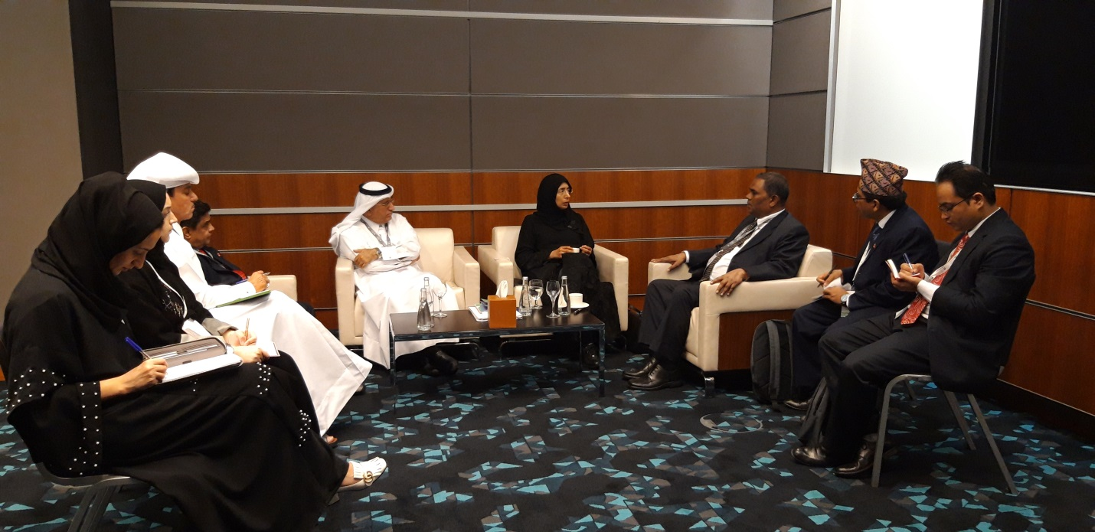
Hon. Mr. Upendra Yadav, Deputy Prime Minister and Minister for Health and Population holding meeting with Her Excellency Dr. Hanan Mohamed Al Kuwari, Minister of Public Health of the State of Qatar

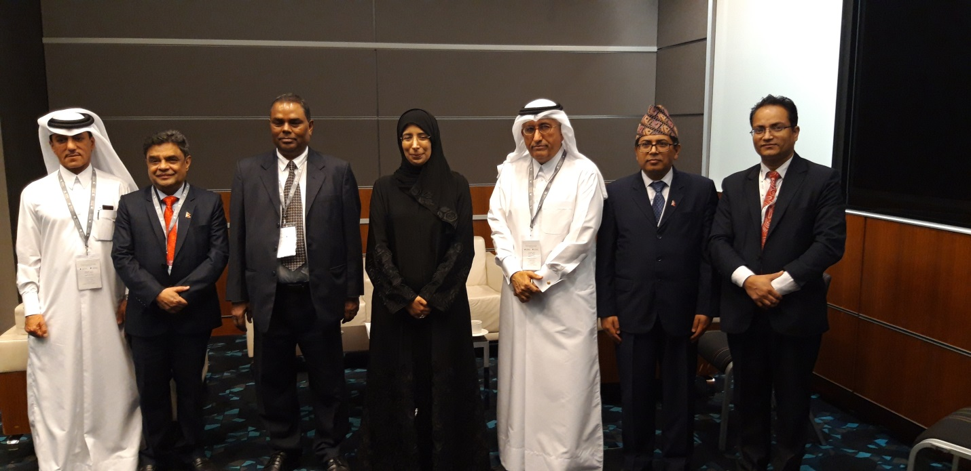

Hon. Mr. Upendra Yadav, Deputy Prime Minister and Minister for Health and Population holding meeting with Her Excellency Dr. Hanan Mohamed Al Kuwari, Minister of Public Health of the State of Qatar

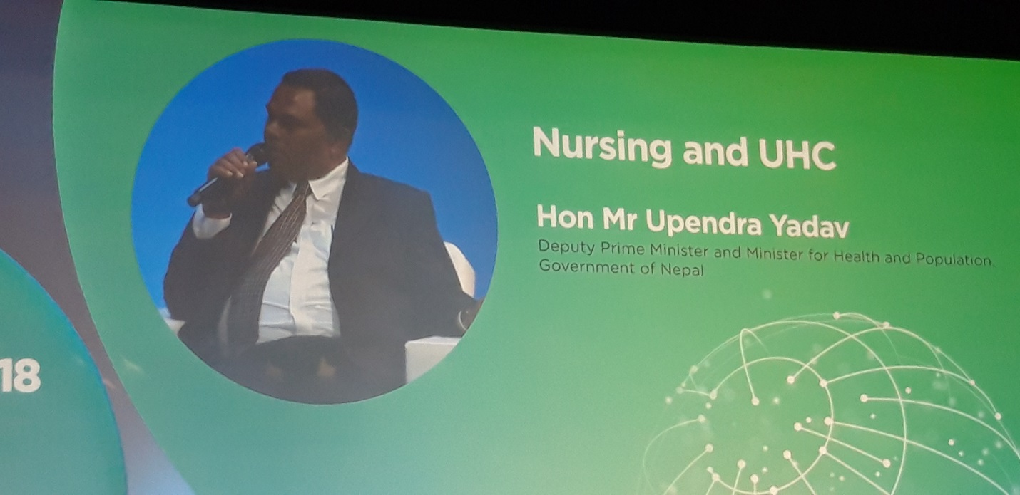

Hon. Mr. Upendra Yadav, Deputy Prime Minister and Minister for Health and Population speaking at the High Level Panel Discussion of World Innovation Summit for Health on Nursing and UHC.

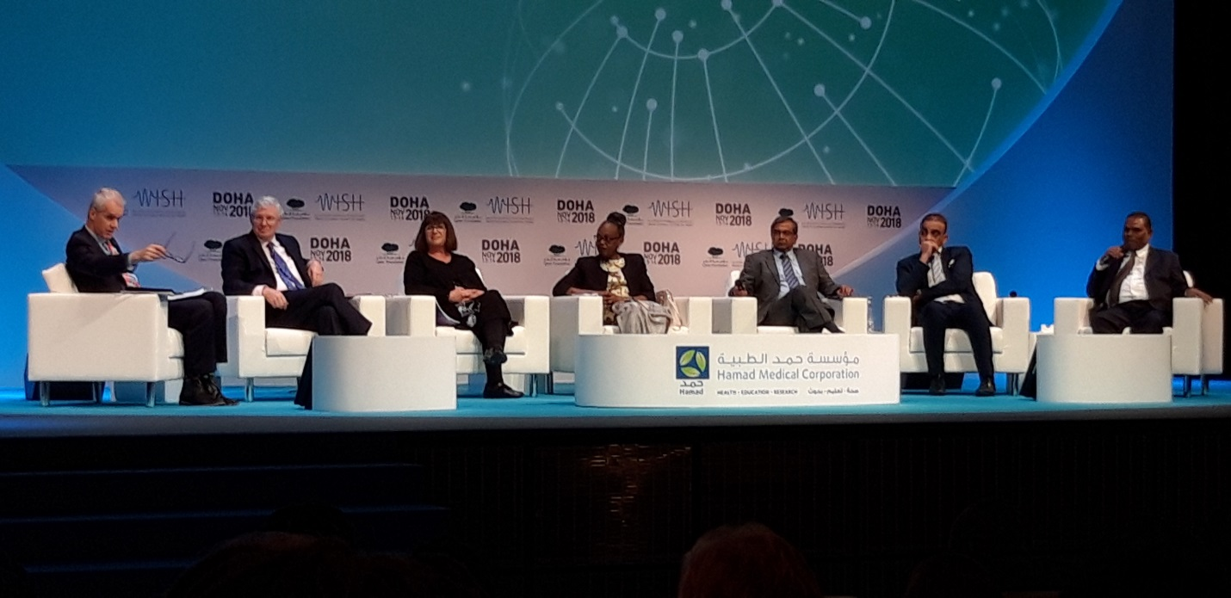

Hon. Mr. Upendra Yadav, Deputy Prime Minister and Minister for Health and Population taking part at the High Level Panel Discussion of World Innovation Summit for Health on Nursing and UHC.

